Draft Lewis River Wildlife
Habitat Management Plan
FERC Project Nos. 935, 2071, and 2111

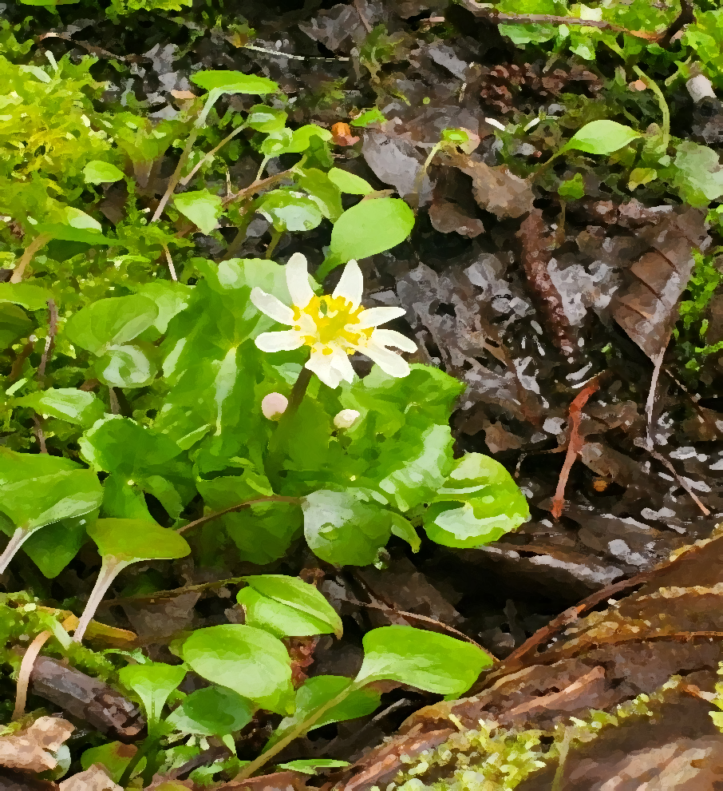

2023 Annual Plan
Annual Plan for Operations Phase 2023
April 17, 2023

Table of Contents

1.0 Introduction 1
2.0 Wildlife Habitat Management Plan Funding 1
3.0 Land Acquisition 1
4.0 Administration 2
4.1 Terrestrial Coordination Committee 2
4.2 Annual Report 2
4.3 Annual Plan 2
4.4 Restoration Plans 2
5.0 Old-growth Habitat Management 3
5.1 Inspections 3
5.2 Management Actions 3
6.0 Wetland Habitat Management 3
6.1 Inspections 3
6.2 Management Actions 3
7.0 Riparian Habitat Management 7
7.1 Inspections 7
7.2 Management Actions 7
8.0 Shrubland Habitat Management 7
8.1 Inspections 7
8.2 Management Actions 7
9.0 Farmland, Idle Areas, and Meadows Habitat Management 8
9.1 Inspections 8
9.2 Management Actions 9
10.0 Orchard Management 11
10.1 Inspections 11
10.2 Management Actions 12
11.0 Transmission Line Right-of-Way Habitat Management 12
11.1 Inspections 12
11.2 Management Actions 12
12.0 Unique Area/Habitat Management 13
12.1 Inspections 13
12.2 Management Actions 13
13.0 Forestland Habitat Management 14
13.1 Inspections 14
13.2 Management Actions 14
14.0 Invasive Plant Species Management 22
14.1 Prevention 22
14.2 Detection 22
14.3 Treatment 22
14.4 Monitoring 23
15.0 Raptor Site Management 23
15.1 Monitoring 23
15.2 Habitat Enhancement 23
15.3 Best Management Practices 24
16.0 Public Access Management 24
16.1 Inspections 24
16.2 Management Actions 24
17.0 Monitoring 25
18.0 References 26

Figures

Figure 1. Swift Bypass Wetland 2 still requires RUAR treatment in 2023 5
Figure 2. North and South IP Pond Five Year Treatment Plan 6
Figure 3. RUAR in Shrubland 3-2a 8
Figure 4. Big Hemlock Meadow showing sparce vegetation 11
Figure 5. Oak site 6-45 with several volunteer Douglas fir seedlings 14

Tables

Table 1. Reed Canarygrass treatment in Frasier Creek Wetlands 4
Table 2. North and South IP Pond Five Year Treatment Plan 6
Table 3. Noxious Weed Control Treatments on Transmission Lines 13
Table 4. Management Unit 3 Proposed Timber Harvest Areas 15
Table 5. Management Unit 20 Proposed Timber Harvest Areas 16
Table 6. Management Unit 28 Proposed Timber Harvest Areas 16
Table 7. Management units proposed for future timber harvest 17
Table 8. 2023 Tree Planting 18
Table 9. 2023 Seedling Maintenance and Protections 18
Table 10. 2023 THA vegetation control treatments 20
Table 11. 2023 Pre-commercial Thinning and pruning treatments 22
Table 12. 2023 Invasive Plant Species Control Treatment Sites 23

Appendices

Appendix A 2023 Budget
Appendix B Terrestrial Coordination Committee 2023 Annual Plan Consultation Record
Appendix C 2023 Proposed Timber Harvest Area Maps
Appendix D 2023 Regeneration Practices Maps
Appendix E 2023 Invasive Plant Species Control Maps
Appendix F Wildlife Forage Monitoring Map
Appendix G Pollinator Plots

Acronyms & Abbreviations
To enhance readability, the use of acronyms and abbreviations has been minimized in this document. However, for longer terms that are frequently used throughout the document, as well as certain units of measurement, the following acronyms and abbreviations have been used.
ABPR Noble fir (Abies procera)
ac Acre(s)
ACMA Bigleaf Maple (Acer marcrophyllum)
ALPE Garlic mustard (Alliaria petiolata)
ALRU Red alder (Alnus rubra)
BUDA butterfly bush (Buddleja davidii)
CC Clearcut
C:F cover:forage
CIAR Canada thistle (Cirsium arvense)
CIVU Bull thistle (Cirsium vulgare)
CT Commercial Thin
CYSC Scotch broom (Cystisus scoparius)
dbh diameter at breast height
FERC Federal Energy Regulatory Commission
GELU Shiny geranium (Geranium lucidum)
GIS Geographic Information System
GLSG Grass/Legume Seed Germination
HEHE English Ivy (Hedera helix)
HEMP Habitat Enhancement Monitoring Project
ILAQ English Holly (Ilex aquifolium)
IMGL Policeman’s helmet (Impatiens glandulifera)
IRPS Yellowflag iris (Iris pseudacorus)
LALA Perennial pea (Lathyrus latifolius)
LWD Large woody debris
MAOR Manroot (Marah oreganus)
MMFEEM Marble Mountain Forage Enrichment and Effective Monitoring
MU Management Unit
P Pole Conifer
PCT Pre-commercially thin
PFO Palustrine Forested Wetland
PHAM Pokeweed (Phytolacca americana)
PIMO Western white pine (Pinus monticola)
PHAR Reed canarygrass (Phalaris arundinacea)
PSME Douglas-fir (Pseudotsuga menziesii)
PTAQ Western Brackenfern (Pteridium aquilinum)
RUAR Himalayan blackberry (Rubus armeniacus)
RULA Evergreen blackberry (Rula laciniatus)
RUSP Salmonberry (Rubus spectabilis)
TCC Terrestrial Coordination Committee
THA timber harvest area
THPL Western red cedar (Thuja plicata)
VES Visual Encounter Surveys
WDNR Washington Department of Natural Resources
WHMP Wildlife Habitat Management Plan

Introduction
This Annual Plan fulfills PacifiCorp’s obligations for the license’s Article 403 and Settlement Agreement 10.8.3 (Federal Energy Regulatory Commission [FERC] 2008a, FERC 2008b, FERC 2008c, PacifiCorp et al. 2004). The objective of this plan is to detail the terrestrial protection, mitigation, and enhancement measures that are planned to be implemented on Lewis River Wildlife Habitat Management Plan (WHMP) lands in the current operational year (i.e., January 1 to December 31, 2023) (PacifiCorp 2008). This plan also provides details on available WHMP funding, outlines proposed costs, and demonstrates consistency with the Lewis River WHMP goals and objectives, and state and Federal regulations.

Wildlife Habitat Management Plan Funding
Settlement Agreement 10.8.2.1 describes the annual funding for PacifiCorp lands managed under the WHMP as $27 (in 2003 dollars, Adjusted for Inflation) per acre owned in fee simple and
$13.50 (in 2003 dollars, Adjusted for Inflation) per acre for other Interests in Land (e.g., conservation easements) (PacifiCorp et al. 2004). As of December 31, 2022, PacifiCorp, has 15,816 acres (ac) of WHMP lands owned in fee simple and 16 ac of Interests in Lands. PacifiCorp is continually refining their property lines through surveys and reviewing title reports as needed, so it is expected that fee simple acres will vary slightly each year.
The 2023 WHMP budget as of January 1, 2023, will be a total of $883,786.03 which includes the cost per acre for fee simple ($677,314.75) plus interest ($32,945.94) and conservation easement lands ($336.92), and remaining funds from the previous year ($173,188.42). Appendix A provides the overall 2023 budget as well as the budgets for administration, management areas, and plan- wide goals. To accurately reflect costs, the 2023 budget is based on costs expended in prior years, which may differ from original estimates in the WHMP (PacifiCorp 2008).

Land Acquisition
In accordance with the Settlement Agreement 10.1, 10.2, and 10.3, PacifiCorp has established the Yale Land Acquisition and Habitat Protection Fund, the Swift No. 1 and Swift No. 2 Land Acquisition and Habitat Protection Fund, and the Lewis River Land Acquisition and Habitat Protection Fund, which are referred to as the Yale, Swift, and the Lewis River funds respectively. Article 403 in the Yale and Swift 1 licenses require that the annual plan describe how the funds are to be used and the lands proposed to be acquired under these funds.
The Yale Fund (Settlement Agreement 10.1) was fully expended as of December 31, 2010, for the 2010 land acquisitions. No further contributions are scheduled. The purchases were accomplished with additional funding supplied from the Lewis River Fund with the Terrestrial Coordination Committee (TCC) approval.
The Swift Fund (Settlement Agreement 10.2) is currently $31,532.09 as of December 31, 2023, which includes 2022 interest. This fund has received all of its contributions. The TCC will need to determine how to spend the remaining funds.
The Lewis River Fund (Settlement Agreement 10.3) was fully expended as of April 30, 2017, to complete the 2017 land acquisition. However, it was determined in 2021 that there was error in the how the funds were dispersed in 2017. The amount of $163,950 was refunded to account.

Administration

Terrestrial Coordination Committee
Settlement Agreement Section 14.2.5 requires that the TCC meet at least annually and during the development of the WHMP the TCC met at least monthly. Since the WHMP is entering into the Fourteenth year of the WHMP implementation (15th license year), the TCC meetings for 2023 are currently scheduled for monthly but may occur on an as-needed-basis and as decided by the TCC.

Annual Report
An Annual Report describing the terrestrial protection, mitigation, and enhancement measures that occurred on WHMP lands during 2022 was submitted to the TCC for the 30-day review April 14, 2022.

Annual Plan
TCC members were provided a draft of this report April 14, 2023, to review and provide comments within 30 days or by May 14, 2023. These comments were either incorporated into this report or if not, an explanation has been provided and included in Appendix B. In accordance with the Settlement Agreement 14.2.6, this report was in the past submitted to the FERC no later than 30 days, or by April 15th each year. However, in 2022 PacifiCorp requested and was approved for an extension of the compiled ACC/TCC annual report to be submitted each year by June 30th. The extension is necessary to provide adequate time for aquatic information.

Restoration Plans
No lands were identified as significantly damaged by anthropogenic processes in 2022; therefore, no restoration plan is required in 2023.

Old-growth Habitat Management

Inspections
Old-growth aerial surveys will be conducted concurrently with the osprey (Pandion haliaetus) and bald eagle (Haliaeetus leucocephalus) nest aerial surveys (Section 15.1). Due to the difficulty in differentiating between the costs for each survey, the funds budgeted for the osprey and bald eagle nest survey include the costs of the old-growth aerial survey.

Management Actions
The old-growth connectivity data layer will be reviewed for 2023 and future habitat management decisions to ensure the priority mature stands are maintained and, where feasible, implement management actions (e.g., snag development, large down wood, thinning) that would promote old-growth habitat in those areas.
A population of English Ivy (Hedera helix) in old-growth area in MU 2 south of the 230 road will be monitored and treated, if needed.

Wetland Habitat Management

Inspections
The 5-year inspection of managed and unmanaged wetlands will be completed between April and June 2023. Post- treatment inspection will occur at Cedar Grove, Chestnut, and Banker’s Ponds to monitor the effectiveness of reed canarygrass (Phalaris arundinacea) [PHAR] control treatment from 2016 -2022. The Himalayan blackberry (Rubus armeniacus) treatment at Swift Canal Ponds, Swift Bypass Wetland 2 and Wetland 2 Constructed Channel will be inspected and GPS’d. PacifiCorp records will be updated as needed.

Management Actions
Management actions scheduled to occur in 2023 include the stop log removal/replacement for bullfrog (Rana catesbeiana) management and high winter flows, and to review the Washington Department of Natural Resources (WDNR) Heritage Database. Bullfrog monitoring and management will continue this year, with Visual Encounter Surveys (VES) at Frasier Creek wetlands (Cedar Grove, Chestnut, Road, Banker’s, Cross Road, Borrow Area, and Pumphouse Ponds) (Muths 2011). The objectives will be to learn more about the population and development of bullfrog larva in these ponds to ensure that draining the wetlands is not selecting for a rapidly developing genotype (Adams and Pearl 2007).
The wetlands along Frasier Creek; Cedar Grove, Chestnut, Banker’s, and Road have extensive PHAR along their banks, which is an invasive plant species that diminishes the habitat value for native amphibians. In 2016, the first phase (Table 1) in controlling reed canarygrass along the Frasier Creek wetlands began at Cedar Grove Pond, the first wetland along the diversion. The area was treated using Glyphosate, because Glyphosate is a non-selective herbicide, it was expected that all vegetation mixed within the PHAR infestation will also be killed. Chestnut Pond was treated in 2017 as the second phase of the project. Third phase, Cedar Grove and Chestnut areas were raked, and grass seeded with a native wetland grass/forb mix in 2019 and planted with hydrophytic shrubs. Fourth phase is treating Bankers and Road Pond which had their first treatment in 2020/2021, respectively. If the PHAR treatment appears to be successful, the area will be raked and seeded with the native wetland grass/forb mix and planted with hydrophytic shrubs. These areas will continue to be inspected for effectiveness and, if needed, retreated in March and/or July. As part of the fourth phase PacifiCorp has been treating the PHAR in the stream that connects Banker’s and Road Ponds. It will not be treated with Glyphosate to preserve the shrubs providing red legged frog (Rana aurora) habitat. The stream is cut using a weedwhacker in the spring and again later in summer, it will have the same treatment in 2023. This will be the third year so the effectiveness of this tactic will be reviewed. All ponds will be surveyed and treated as needed. Treatment areas will be photographed as needed to capture the progress.
Table 1. Reed Canarygrass treatment in Frasier Creek Wetlands
 | Cedar Grove | Chestnut | Bankers | Stream Between Ponds | Road | Frasier Creek
Phase | 1, 3 | 2, 3 | 4 | 4 | 4 | 2
Treatment Year(s) | 2016 - 2023 | 2017 - 2023 | 2020 -2023 | 2021 -2023 | 2022 - 2023 | 2018, 2021
Raked and Reseeded | 2019 | 2019 | 2023? | Check for Treatment Success 2023 | 2024 | Check for Treatment Success 2023
Plantings | 2021 | 2021 | 2021 | N/A | 2024 | N/A
Yellowflag Iris (Iris pseudacorus [IRPS]) is a Class C noxious weed that has been detected in the northwest corner of Beaver Bay Wetland. Controlling IRPS in this area is difficult due to deep mud and distinguishing this plant form other native fauna. The area will continue to be monitored for extent and location of the infestation(s) between April 1st and May 15th. This will be followed by a treatment of aquatic approved Glyphosate between May 15th and June 15th and follow-up treatment September 15th to October 15th with aquatic approved Imazapyr (King County 2009).
In 2017, twelve WHMP Palustrine Forest (PFO) wetlands were evaluated to determine if they exceeded 20 percent shrub cover and determine what, if any, management actions are needed to enhance shrubs. Only 4 of the wetlands were at or below 20 percent shrub cover and they were planted in the spring of 2018. Six PFO wetlands have excessive amounts of Himalayan blackberry that were outcompeting native shrubs, these wetlands have been treated for Himalayan blackberry beginning in 2018 and will be continuing into 2023. They will be evaluated the following year to determine if Himalayan blackberry has been effectively controlled and if native shrubs begin to reestablish. In addition, three PFO wetlands forested canopy are mostly comprised of declining red alder (Alnus rubra). Therefore, to restore the forested canopy these areas will be planted with a mix of Sitka spruce (Picea sitchensis), western red cedar (Thuja plicata), Oregon ash (Fraximus latifolia), red alder, and black cottonwood (Populus balsamifera L ssp. Trichocarpa). In 2023 Swift Canal Ponds, Swift Warehouse, and Swift Bypass wetland 2 will have its fourth year’s survey to determine success of plantings and continued Himalayan blackberry treatment. Swift Bypass will be treated for Scotch broom (Cystisus scoparius [CYSC]) as well. The treatment of RUAR in Swift Bypass Wetland 2 has been very successful. Areas where treatment is not required will be planted with black cottonwood and western red cedar.
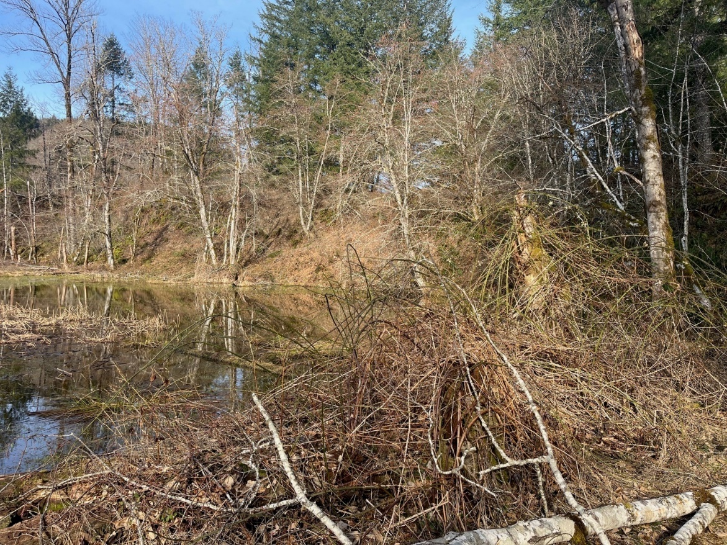
Figure 1. Swift Bypass Wetland 2 still requires RUAR treatment in 2023
North IP Ponds is inundated with reed canarygrass and the road between the two ponds is growing over with Himalayan blackberry. Treatment of all noxious weeds will be costly due to the lack of access to wetland. The road currently is not drivable. PacifiCorp has been treating the Frasier Ponds for PHAR for 6 years with success but repeat treatment is required. PacifiCorp has developed a five-year plan to treat the RUAR and plant conifers (western red cedar, sitka spruce, and western hemlock) which have shown to shade out the PHAR. This will reduce the need to retreat the PHAR every year. The plan required visits over the next 3-4 years to make sure the conifers aren’t outcompeted by the PHAR and have a chance to grow.
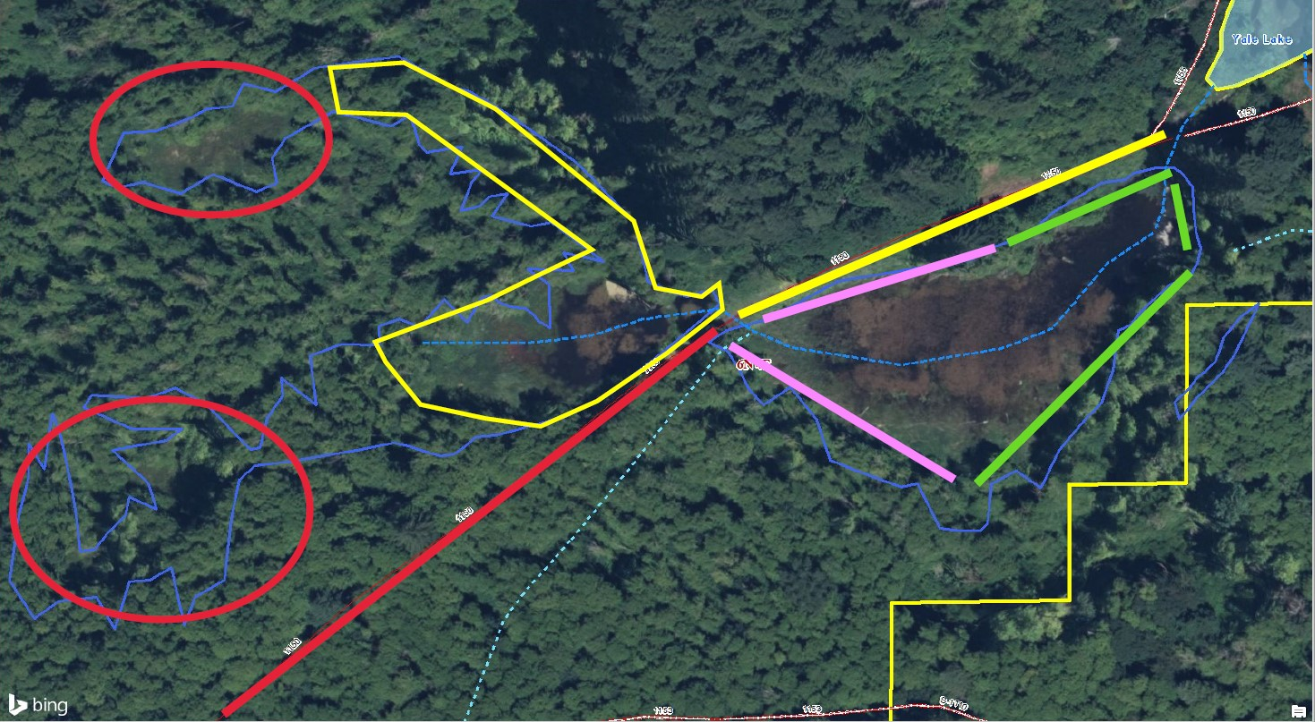
Figure 2. North and South IP Pond Five Year Treatment Plan
Table 2. North and South IP Pond Five Year Treatment Plan
Year | Treatment Plan
2023 | Planting of black cottonwood and western red cedar will occur in red circles. Weed eat planting area and line with weed barrier. Spray with Plantskydd® and cover with vexar tubes. Treat RUAR.
2024 | Revisit 2023 planting areas. Weed eat around new plantings and treat as needed. Plant new plantings (conifers) within yellow polygon. Plantskydd® all plantings in spring. RUAR treatment along yellow line and revisit 2023 treatment area.
2025 | Revisit 2023 and 2024 planting areas. Weed eat around plantings and treat as needed. New plantings will be planted along pink line. Plantskydd® all plantings in spring. Revisit 2023 and 2024 RUAR treatment areas and treat as needed.
2026 | Revisit 2023, 2024, 2025 planting areas. Weed eat around plantings and treat as needed. New plantings will be planted along green lines. Plantskydd® all plantings in spring. Revisit 2023 and 2024 H. blackberry treatment areas and treat as needed.
2027 | Revisit past plantings and treatment areas. Monitor and continue management as needed.
Noxious weed treatment is required at several wetlands. There may not be enough budget to cover all the areas, so the areas will be prioritized in the following order:
- Swift Canal Ponds will have another Himalayan blackberry treatment
- Swift Bypass Wetland 2 will have Himalayan blackberry, holly, and scotch broom treatment
- Beaver Bay Wetland will be treated for Himalayan blackberry and yellow flag iris
- Cresap Pond will be retreated for Himalayan blackberry
A colony of great blue heron (Ardea Herodias) has been detected in Beaver Bay Wetland. PacifiCorp will develop a colony management plan for this site in 2023.

Riparian Habitat Management

Inspections
No inspections are required for Riparian Habitat.

Management Actions
The riparian habitat management actions that are expected to occur in 2022 include:
- Establishing buffers as necessary around the 2023 timber harvest activities,
- Developing water type modifications as necessary for 2023 and 2024 forestry activities.
- Implementing pre-commercial thinning in WHMP riparian buffers is scheduled to occur in older (>15 years) timber harvest area (THA) and newly acquired lands that were planted too heavily to meet WHMP objectives. This includes the following THA: 113319CC (Priority 4), 063309CC (Priority 3), 124010CC (Priority 1), 124012CC (Priority 1), 124013CC (Priority 2), 124018CC (Priority 2) and 124020CC (Priority 3).
- An additional portion of Speelyai Creek on PacifiCorp lands will be treated for invasive plant species. This is in Management Unit (MU) 17 and is targeting Himalayan blackberry.
- The WHMP riparian area in MU 32 is a non-fish perennial stream that has several invasive plant species. This area will be evaluated, and a restoration plan will be developed to control invasive plant species.
- A stream in Management Unit 25 that parallels 2510 road will have western red cedar (Thuja plicata) plantings to replace the mature red alder that is rapidly declining.

Shrubland Habitat Management

Inspections
Shrublands are on a three-year survey rotation. Shrubland 4-6b and 4-6d are next in rotation and scheduled to be inspected between April 15th and October 31st. Shrubland 6 was treated for ivy in 2022. A post treatment survey is required 2023.

Management Actions
A review of the effectiveness of shrubland management actions using annual shrubland inspections will continue to be conducted this year. Some light trimming and RUAR treatment is needed in 3-2a in 2023 (Figure).
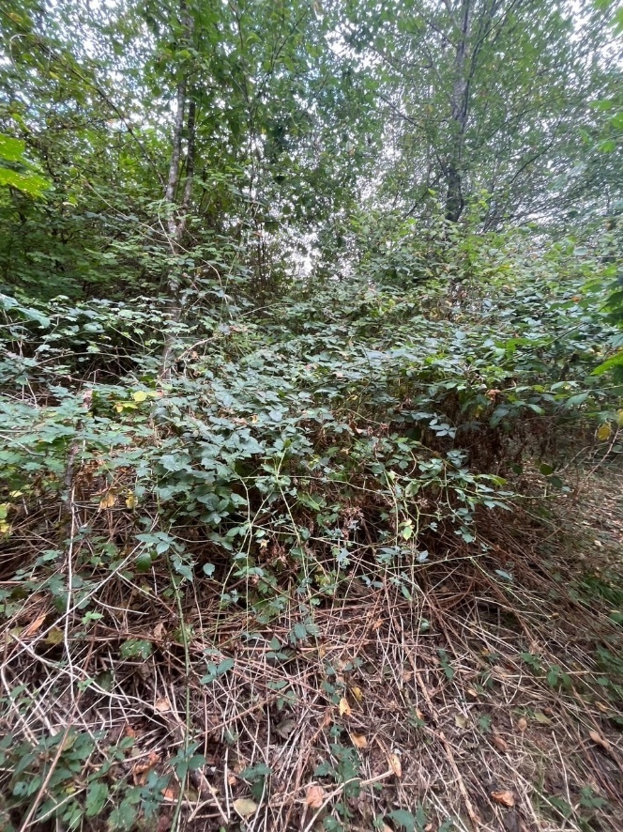
Figure 3. RUAR in Shrubland 3-2a

Farmland, Idle Areas, and Meadows Habitat Management

Inspections
This annual spring inspection will include all farmland, idle fields, and actively managed meadows and occur between April 15th and May 31st. Most of the fields that are actively managed in the spring will be surveyed for Savannah Sparrow (Passerculus sandwichensis), a Habitat Evaluation Procedure (HEP) Species for Farmlands, Meadows and Idle Areas, between April 15th and May 31st to determine occupancy and gain more insight on nest habitat use. Fields will be surveyed using the Area Search method described in Handbook of Field Methods for Monitoring Landbirds (Ralph et al. 1993).

Management Actions
Regularly scheduled annual management actions will occur in 2023 and will include:
- Many of the fields need invasive plant species control, but it is unlikely that all the work can be completed with the short spray window and available budget. Therefore, the following meadows and fields are listed by priority:
  - Osprey Meadow will be treated for Canada thistle (Cirsium arvense)
  - McKees with be mowed for red-veined dock (Rumex sanguineus)
  - Speelyai will be monitored for stinging nettle. If still present it will be mowed and sprayed.
  - Leach with be monitored for CIAR, tansy ragwort, and alder
  - Saddle Dam Farm Fields will be monitored for CIAR and hawthorn
  - Buncombe Hollow will be treated for snowberry growth
  - Winter Creeks will be monitored for CIAR and RCG
  - Rhododendron and Swift will be monitored for tansy ragwort (Senecio jacobaea) and CIAR
- Annual spring mowing at:
  - Saddle Dam Farmlands fields including Idle Field 1/2
  - Upper and Lower McKee
  - Hamm Meadows 1, 2, and 3
  - Buncombe Hollow
  - Lower Hanley Curry
  - Swift Warehouse Meadow
- Annual fall mowing at:
  - Bridge
  - Buncombe Hollow
  - Hamm Meadows 1-5
  - Upper Hanley Curry
  - Lower Hanley Curry
  - Upper McKee
  - Lower McKee
  - Osprey
  - Reese Meadow
  - Rhododendron
  - Saddle Dam Farm Fields 1-5 and Idle Field 1/2
  - Speelyai
  - Swift Warehouse
  - Upper Winter Creek
  - Lower Winter Creek
Meadows in the high country; Mountain View, Big Hemlock, Little Hemlock, and No Hemlock were created and seeded in 2018. The germination of seeds has been very sparce (Figure 4) to date. PacifiCorp will test the soil to determine if any nutrient deficits exist. If required, PacifiCorp has a large pile of ash from the swift drift burn piles that can be spread over the meadows.
- To distribute soil testing costs, managed meadows are tested every other year. Soil testing will be conducted at:
  - Mountain View
  - Big Hemlock
  - Little Hemlock
  - No Hemlock
  - Saddle Dam 1, 2
  - Hamm 1, 2 and 3
  - Bridge
  - Buncombe Hollow
  - Pioneer
  - Upper and Lower Mckee
  - Rhododendron
  - Speelyai
  - Swift
- All managed meadows are fertilized annually based on soil testing results from the soil test from the year before or the year of depending on rotation. We also generalize need biased on what is required in other fields and what is the most economical. Annual fall fertilizing will be based on soil testing and will be conducted at:
  - Saddle Dam Field 1, 2, 3, 4 and 5
  - Bridge
  - Buncombe Hollow
  - Hamm 1, 2, 3, 4 and 5
  - Upper and Lower McKee
  - Pioneer
  - Upper and Lower Winter Creek
  - Rhododendron
  - Speelyai
  - Swift Warehouse
  - Reese Meadow
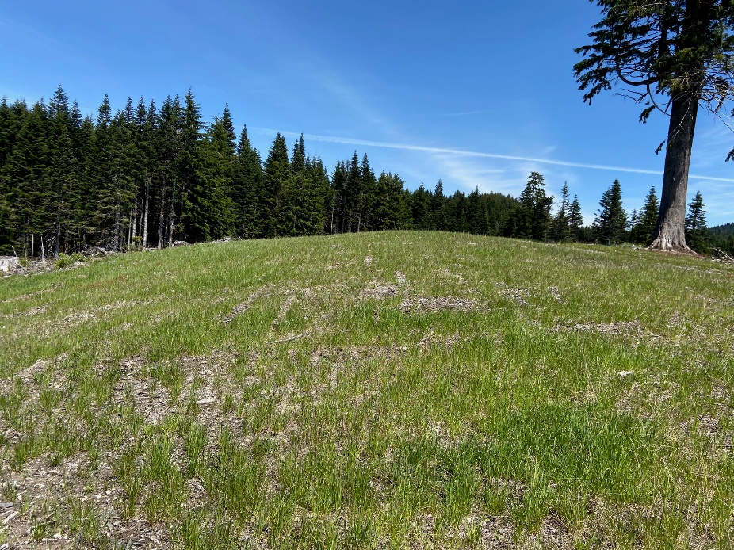
Figure 4. Big Hemlock Meadow showing sparce vegetation

Orchard Management

Inspections
In 2023 PacifiCorp will be conducting the five-year inspection on all orchards:
- Speelyai
- Saddle Dam 1 and 3
- Saddle Dam Road
- Pomona
- Upper and Lower Hanley Curry
- Rhododendron
- Reese Meadow
- Winter Creek
- Hamm Meadow 1
- Hamm Meadow 4
- Hamm Meadow 5

Management Actions
Dormant pruning is scheduled to occur at:
- Buncombe Hollow
- Speelyai
- Saddle Dam 1 and 3
- Saddle Dam Road
Plantings will occur at:
- No plantings are scheduled for 2023
Vegetation control will occur at:
- Saddle Dam 1 and 3
- Saddle Dam Road
- Buncombe Hollow
- Speelyai
Fall mowing will occur at Buncombe Hollow, Lower Hanley Curry, Upper Hanley Curry, and Speelyai orchards along with the spring mowed meadows between August 15th – 31st to maintain big game forage.
Supplemental watering will occur, as needed, in July, August, and September on trees that were planted within the last 3 to 4 years.

Transmission Line Right-of-Way Habitat Management

Inspections
The annual inspection will be completed in 2023 and this inspection should be adequate to assess the post-treatment areas of 2022.

Management Actions
Transmission Line Right-of-Way (ROW) management actions that are scheduled to occur in 2023 include annual mowing at Speelyai 1/11-3/11, Woodland Park West (Speelyai 8/14-9/14), Wilkinson (Speelyai 5/15-7/15) and Lake 3/10-4/10 ROW forage areas. Soil testing and fertilization occurs every other year and is not required in 2023.
Noxious weed control treatments will occur at the following spans (Table 3). There may not be enough budget to cover all the areas, so the areas will be prioritized in the following order:
Table 3. Noxious Weed Control Treatments on Transmission Lines
Transmission Line | Section | Treatment | Management Unit
Kalama | 6/1-7/1 (PL) | CYSC, RUAR | 32
Kalama | 6/1 | CYSC | 32
Kalama | 5/1 – Lewis River | HEHE | 32
Kalama | 1/1 - 3/1 | ACMA | 16
Battle Ground | 1/1 – 2/1 | ACMA | 16
Cougar | 1/1 - 4/1 | CYSC, RUAR | 21
Speelyai | 3/14 | ACMA | 4
Beaver Bay (Speelyai Line 7/1-11/1) is a series of wetlands and springs beneath the line that are dominated with Himalayan blackberry. The Beaver-Cougar trail was completed in 2017 and allows access to the area. The trail has had extensive Himalayan blackberry treatment since trail completion. In 2023 we will return to the area and determine the effectiveness of 2022 treatment for Himalayan blackberry and Scotch broom. The hydrology will be assessed to determine the existing native vegetation and potential for it to reestablish from recovering Himalayan blackberry areas.
Pollinator testing sites will continue to be monitored (Appendix G) and seed mixes will continue to be a priority in 2023. All sites will be monitored for noxious weeds and treated as needed. The seeded pole replacement sites from 2020, 2021, and 2022 will be monitored in 2023. New poles are scheduled to be replaced in 2023. It will be the last seed mix for this test. Final seed mix selection will be determined after this last mix grows and is surveyed in 2024.

Unique Area/Habitat Management

Inspections
The annual inspections will occur at oak stands 6-22a, 6-22b, 6-23, 6-26a, and 6-26b. Follow up survey will occur at oak site 1-12 to determine extent of oak die off.

Management Actions
Due to a concern by the TCC about low overall mast production on most oak stands on PacifiCorp property a new management strategy is being tested. Oak sites 5-1 and 5-2 are the first areas for treatment which started in 2020. To encourage further growth of naturally germinated seedlings, Plantskydd® has been used to treat selected seedlings while allowing others to continue to be browsed. The selected oak seedlings will continue to be treated once in spring and again in the fall for the next year (ending in 2023). This will allow successful growth for future generations of oaks while still allowing forage opportunity. PacifiCorp will report on the tracked expense and success for the project and will report to TCC the validity to continue for future management areas.
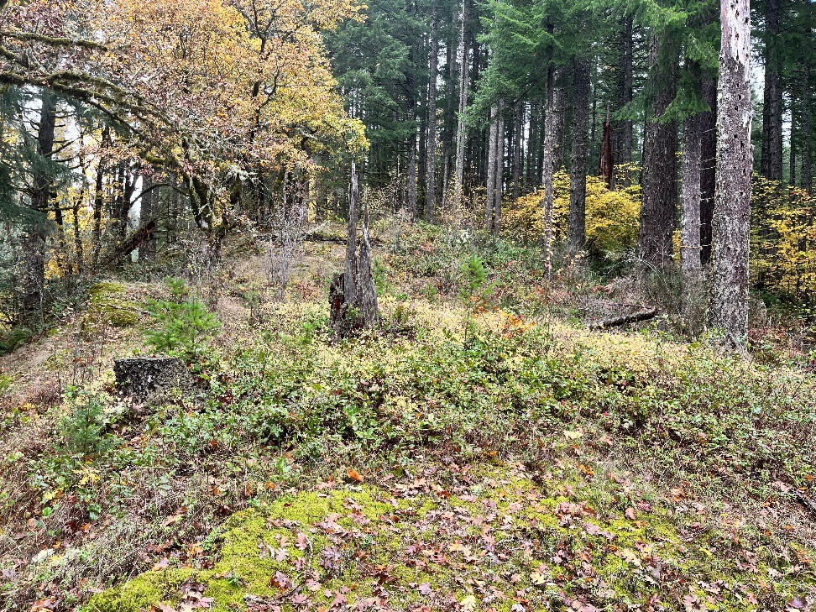
Figure 5. Oak site 6-45 with several volunteer Douglas fir seedlings
Oak site 1-12 will be surveyed in 2022 to determine health of trees after they were determined to be struggling after the heat wave in June 2021. Figure 3 shows the volunteer Douglas fir seedlings that will be removed along with other shrubs crowding the oak seedling growth in oak site 6-45 (Figure 5). This was scheduled to occur in 2022 but was not accomplished.

Forestland Habitat Management

Inspections
The annual spring and fall timber harvest area (THA) inspections (i.e., reforestation inspections) will occur in 2023. Inspections and supervision will ensure implementation of harvest area maintenance practices, determining success of past practices and provide assurance that forestland management is meeting wildlife habitat objectives.

Management Actions
Forestland management in 2023 includes developing new areas of transitional forage for big game and maintaining areas of previous forest management to provide diverse cover and forage for a variety of wildlife in stands ranging from 1 to 60 years of age. Appendix C includes maps of the proposed areas. These areas are explained in more detail below.

2023 Proposed Forestland Practices
A total of 17.7 acres are proposed for even-age [clearcut (CC) and 20.9 acres of commercial thinning (CT) in MUs 3, 6, and 35. These areas are described separately below and showing in Appendix C.

Management Unit 3
Management Unit 3 consists of 298.65 acres and is on the north side of Merwin Reservoir between Day and Indian George creeks. The current Cover:Forage (C:F) ratio is 70:30 and the WHMP recommended ratio is 60:40 (+ 5%), therefore the current management is not meeting objectives. Following the proposed 2023 timber harvest the C:F ratio is estimated to be 65:35. The final acreage may be adjusted to provide for riparian habitat or other special management areas. There are no known northern spotted owl (Strix occidentalis) circles within the THA boundaries of MU 3 or priority mature areas. The following harvest are proposed (Table 4).
Table 4. Management Unit 3 Proposed Timber Harvest Areas
THA Name | Current THA number | Former THA Number | Total Acres | Proposed Harvest | Vegetation Cover Types1
Calamity Jane | 220328 CT | 880328CC | 12.5 | Commercial Thin | P =12.5
Total Commercial Thin acres |  |  | P=12.5
Total Commercial Thin Acres  Timber Harvest Acres |  |  | 12.5  12.5 |  | P = 12.5
¹Pole Conifer (P) = Canopy cover consist of >70% conifer and the average stand diameter is 8”-15” dbh.

Management Unit 20
Management Unit 20 is located at on the north side of Yale Reservoir near the town of Cougar. The MU is a total of 934.7 acres and is mostly forested habitat. The current C:F ratio is 89:11 and the WHMP recommended ratio is 85:15 (+ 5%), therefore the current management is not meeting C:F objectives. Following the proposed 2023 timber harvest the C:F ratio is estimated to be 86:14. The final acreage may be adjusted to provide for riparian habitat or other special management areas. A portion of a known historic northern spotted owl circle is within the boundary of the Porky Pig (232028CC) THA. The entire area is classified as Pole and the average diameter breast height of 8”-15” inches. The harvest is a commercial thin that would retain 50% of the canopy cover and would not remove any tree that is > 21 inches dbh. The following harvest are proposed (Table 5).
Table 5. Management Unit 20 Proposed Timber Harvest Areas
THA Name | Current THA number | Former THA Number | Total Acres | Proposed Harvest | Vegetation Cover Types1
Porky Pig | 232028 CT | 912002CC | 8.3 | Commercially Thin | P = 8.3
Elmer Fud | 220662 CC |  | 9.0 | Clear Cut | P= 9.0
Total Commercial Thin acres Total Clearcut Harvest acres Total Timber Harvest Acres |  |  | 8.3  9.0  17.3 |  | P =17.3
1 Pole Conifer (P) = Canopy cover consist of >70% conifer and the average stand diameter is 8”-15” dbh

Management Unit 28
MU 28 is where the North Fork Lewis River enters into Swift Reservoir. The MU 28 is a total of 153.8 acre and 75.4 or 49% is manageable acres. The current C:F ratio is 95:5 and the recommended C:F ratio is 50:50 (+ 5%), therefore the current management is not meeting C:F objectives. MU 28 also doesn’t meet permanent forage percent. Following the proposed 2023 timber harvest the C:F ratio is estimated to be 90:10. The final timber harvest acreage may be adjusted to provide for riparian or wetland habitat or other special management areas. There are no known northern spotted owl circles within the THA boundaries of MU 35 or priority mature areas. The following harvest are proposed (Table 6).
Table 6. Management Unit 28 Proposed Timber Harvest Areas
THA Name | Current THA number | Former THA Number | Total Acres | Proposed Harvest | Vegetation Cover Types1
Eagle Cliff | 223502CC | None | 7.1 | Clearcut | P = 7.1
Total Commercial Thin Acres Total Clearcut Harvest acres Total Timber Harvest Acres |  |  | 0.0  7.1  7.1 |  | P=7.1
1 Pole Conifer (P) = Canopy cover consist of >70% conifer and the average stand diameter is 8”-15” dbh.

2023 Forestland Planning
Forestland planning in 2023 will continue pre-cut surveys for both the 2023 and 2024 proposed forest plan areas and developing forest plans for near future (Table 7). The TCC will be provided site visits for forest management proposed in Management Unit 20 and 28. The MU 3 timber harvest was evaluated by the TCC in 2022. PacifiCorp continues to update the Geographic Information System (GIS) data and C:F model to ensure compliance with the WHMP plans. In 2018 the Lewis River WHMP Lands Timber Harvest and Silviculture Planning memo was created to provide guidelines and schedules for actions associated with reforestation inspection, replanting, silviculture, and timber harvest to meet WHMP habitat goals and objectives and to effectively manage future budgets and workloads.
Table 7 provides a list of the MUs that will be considered for timber harvest in the next year. These MUs were selected by their current C:F ratio compared to the C:F goal for that MU, years since last harvest, and whether or not some current THAs are ready for commercial thinning. MU 5 and 8 will be evaluated for future proposed timber harvest. Currently 2025 will focus on commercial thin priorities instead of C:F priorities. The MU to be harvested will be determined.
Table 7. Management units proposed for future timber harvest
Management Unit | Total Acres | C:F Ratio | C:F Ratio Objective based on WHMP | Meets 5% permanent forage (Y/N) | Potential Harvest Schedule
5 | 360.5 | 68:32 | 50:50 | N | 2024
8 | 279.0 | 82:18 | 60:4055:45 | Y | 2024

First Precut Survey
First pre-cut surveys will also be conducted for 2024 THA’s in MU 5 and 8.

Harvest Area Traverse and Geographic Information System Update.
The 2023 THAs will be updated in the GIS database following TCC approval of the proposed plans and the completion of the timber harvests. Field work will be completed for the vegetation cover types and stream surveys as necessary and will be entered into the GIS database.

Second Precut Survey
The second precut survey for the 2023 timber harvests will be completed in the early summer following, if possible, TCC review of the sites. Forestry Appendix C maps show the 2023 timber harvest areas delineated boundaries, roads, riparian and wetland buffers. These surveys will ensure that compliance is maintained with resource plans and special habitat components including large woody debris (LWD) and leave tree areas are protected.

Terrestrial Coordination Committee
The 2023 proposed THAs will be reviewed by the TCC in an onsite meeting. The TCC will receive regular updates and coordination throughout 2023 regarding forestland activities.

Timber Harvest Area Inspections
A biologist and/or forester will conduct weekly inspections during the logging operations to ensure that the operations are compliant with WHMP best management practices, contract conditions, State Forest Practices Act, and industry standards.

Regeneration Practices
Regeneration practices include management actions that promote tree regeneration following timber harvests and maintaining or establishing big game forage and cover. The 2023 clearcut timber harvest areas will be site prepped for forage seeding and tree planting by piling residual slash and site prepping soils with a tractor mounted brush blade. Tree planting, vegetation control and pre-commercial thinning practices are described in the following sections.

Planting and Maintenance
The 2023 planting and seedling maintenance activities will include planting the 2022 timber harvest area (MU 6 and 35) as shown in Table 8 and locations are mapped in Appendix D.
Table 8. 2023 Tree Planting
Harvest Area | Acres | Action
220687 CC | 16.0 | Plant 2500 THPL, 1200 PIMO
223502 CC | 4.2 | Plant 550 PSME, 460 ABPR
223503 CC | 5.7 | Plant 950 PSME, 800 ABPR
223504 CC | 3.6 | Plant 600 PSME, 475 ABPR
223505 CC | 7.4 | Plant 1250 PSME, 965 ABPR
Total Acres | 36.9 | 3,350 PSME; 2500 THPL; 2700 ABPR, 1200 PIMO
PSME = Douglas-fir; THPL = Western redcedar; ABPR = Noble fir, PIMO = Western white pine

Seedling Maintenance
To reduce moisture competition between tree seedlings and the grass forage mix, the existing grasses are killed by using a pre-emergent herbicide, such as Sulfometuron (Oust®) or Surflan (for western red cedar) with glyphosate, which is sprayed in an 18-inch radius around all seedlings. Also, seedlings are protected from browse by placing and maintaining protective tubes (Vexar or Protex) and, if needed, sprayed with an application of Plantskydd®. All timber harvest areas that require treatment are listed in Table 9 and locations are identified in Appendix E. Spring surveys may identify additional THA’s requiring additional vegetation control.
Table 9. 2023 Seedling Maintenance and Protections
Timber Harvest Area |  | Total Acres |  | Action
170111 CC |  | 5.0 |  | Retube THPL seedlings missing Vexar or Protex Tubing. Remove Protex tube if leader is within 6 inches of top of tube. Move vexar tubing up the seedling to protect the leader leaving approximately one foot of tubing for future seedling growth. Replace bamboo stakes where needed.
170112 CC |  | 23.9 |  | Retube THPL seedlings missing Vexar or Protex Tubing. Remove Protex tube if leader is within 6 inches of top of tube. Move vexar tubing up the seedling to protect the leader leaving approximately one foot of tubing for future seedling growth. Replace bamboo stakes where needed.
160335 CC |  | 13.1 |  | Retube THPL missing Vexar Tubing. Move vexar tubing up the seedling to protect the leader leaving approximately one foot of tubing for future seedling growth. Replace bamboo stakes where needed. Clear vegetation within 1 foot of THPL.
220687 CC |  | 15.9 |  | Tube THPL with Vexar Tubing. Apply Pendulum and Oust.
170775 CC |  | 1.4 |  | Retube THPL seedlings missing Vexar Tubing. Move vexar tubing up the seedling to protect the leader leaving approximately one foot of tubing for future seedling growth. Replace bamboo stakes where needed.
170776 CC |  | 1.3 |  | Remove all tubes and use twine to secure seedlings to bamboo stakes.
200938 CC |  | 8.3 |  | Retube THPL missing Vexar Tubing. Move vexar tubing up the seedling to protect the leader leaving approximately one foot of tubing for future seedling growth. Replace bamboo stakes where needed. Apply Pendulum and Oust.
211011 CC |  | 7.4 |  | Apply Oust.
211012 CC |  | 12.4 |  | Retube THPL missing Vexar Tubing. Move vexar tubing up the seedling to protect the leader leaving approximately one foot of tubing for future seedling growth. Replace bamboo stakes where needed. Retube ACMA missing Protex Tubing. Replace bamboo stakes where needed. Apply Pendulum and Oust.
211013 CC |  | 11.6 |  | Retube THPL missing Vexar Tubing. Move vexar tubing up the seedling to protect the leader leaving approximately one foot of tubing for future seedling growth. Replace bamboo stakes where needed. Apply Pendulum and Oust.
101127 CC |  | 12.4 |  | Retube THPL seedlings missing Vexar or Protex Tubing. Remove Protex tube if leader is within 6 inches of top of tube. Move vexar tubing up the seedling to protect the leader leaving approximately one foot of tubing for future seedling growth. Replace bamboo stakes where needed.
171401 CC |  | 23.0 |  | Retube THPL missing Vexar Tubing. Move vexar tubing up the seedling to protect the leader leaving approximately one foot of tubing for future seedling growth. Replace bamboo stakes where needed.
181551 CC |  | 10.0 |  | Retube THPL missing Vexar Tubing. Move vexar tubing up the seedling to protect the leader leaving approximately one foot of tubing for future seedling growth. Replace bamboo stakes where needed.
181552 CT |  | 1.5 |  | Retube THPL missing Vexar Tubing. Move vexar tubing up the seedling to protect the leader leaving approximately one foot of tubing for future seedling growth. Replace bamboo stakes where needed.
161904 CC |  | 9.8 |  | Retube THPL seedlings missing Vexar or Protex Tubing. Remove Protex tube if leader is within 6 inches of top of tube. Move vexar tubing up the seedling to protect the leader leaving approximately one foot of tubing for future seedling growth. Replace bamboo stakes where needed.
161908 CT |  | 4.1 |  | Retube THPL seedlings missing Vexar or Protex Tubing. Remove Protex tube if leader is within 6 inches of top of tube. Move vexar tubing up the seedling to protect the leader leaving approximately one foot of tubing for future seedling growth. Replace bamboo stakes where needed.
223502 CC |  | 4.2 |  | Apply Oust.
223503 CC |  | 5.7 |  | Apply Oust.
223504 CC |  | 3.6 |  | Apply Oust.
223505 CC |  | 7.4 |  | Apply Oust.
 | Total |  | 182.070.7

Invasive Plant Control
Invasive plant species and competing vegetation are controlled as necessary to maintain and promote big game forage, maintain access, and to reduce seedling competition. Treatments may include both chemical and manual methods. Because weather can be a limiting factor in completing all vegetation control treatments, priorities from 1 to 4 (1 being the highest priority) have been assigned to each treatment. Of the total 831.3 acres assigned for treatment a total of 15 THAs or 212.97 acres are priority 1, 14 THAs or 267.3 acres are priority 2, 13 THAs or 255.3 are priority 3, and 4 THAs or 95.7 are priority 4. Himalayan blackberry and scotch broom are the primary target species in all but 6 of the 46 treatments. The acres listed are those of the THAs and not necessarily the amount of area to be treated, which is much less. All timber harvest areas that may have vegetation control in 2023 are listed in Table 10 and locations are identified in Appendix E.
Table 10. 2023 THA vegetation control treatments
Timber Harvest Area | Acres | Target Species (spray priority) | Overall Priority
020110 CC | 10.2 | Spray CYSC, Spray RUAR | 3
170107 CT | 8.4 | Spray PTAQ | 3
200234 CT | 22.1 | Spray CIVU, CIAR? | 3
160335 CC | 13.1 | Spray RUAR, RUUR | 2
030447 CC | 24.6 | Spray RUAR | 3
130448 CC | 15.7 | Spray RUAR, CYSC | 2
130449 CC | 1.7 | Spray RUAR, CYSC | 2
130450 CC | 14.9 | Spray RUAR, ILAQ, RUSP | 4
150526 CC | 19.3 | Spray RUAR, CYSC, ALRU | 2
120685 CC | 23.9 | Spray CYSC | 3
970767 CC | 4.4 | Spray CYSC | 2
050771 CC | 2.3 | Spray PHAR | 3
170775 CC | 1.4 | Spray RUAR, CYSC | 2
160773 CC | 26.5 | Spray BUDA, PTAQ | 3
980836 CC | 9.8 | Spray RUAR | 3
170838 CC | 13.8 | Spray PTAQ | 3
200937 CT | 10.4 | Spray CYSC | 1
200938 CC | 8.3 | Spray CYSC, RUAR | 1
2009389 CT | 13.8 | Spray CYSC | 1
200940 CT | 4.8 | Spray CYSC | 1
200941 CT | 2.3 | Spray CYSC | 1
141009 CC | 24.8 | Spray PHAR | 3
141010 CT | 4.0 | Spray RUAR | 1
101127 CC | 12.4 | Spray RUAR, PHAM | 2
021236 CC | 18.4 | Spray RUAR | 4
171401 CC | 23.0 | Spray RUAR, PTAQ | 4
181550 CT | 4.7 | Spray RUAR | 2
181551 CC | 10.0 | Spray RUAR, ALRU | 2
181552 CT | 1.5 | Spray RUAR, ALRU, MAOR | 2
091703 CC | 22.5 | Spray RUAR, PHAM | 2
091705 CC | 11.2 | Spray RUAR | 3
161905 CT | 10.1 | Spray CYSC, RUAR, ALRU | 1
161906 CT | 6.1 | Spray RUAR | 1
161907 CT | 5.0 | Spray RUAR, CYSC | 1
161908 CT | 4.1 | Spray RULA, RUAR, CYSC | 1
063309 CC | 43.4 | Spray CYSC | 3
163651 CC | 49.9 | Spray CYSC, RUAR, ALRU | 1
163652 CC | 45.9 | Spray CYSC, RUAR, ALRU | 1
163653 CC | 20.2 | Spray CYSC, RUAR, ALRU | 1
163654 CC | 42.2 | Spray CYSC, RUAR, ALRU | 1
163655 CC | 40.2 | Spray CYSC, RUAR, ALRU | 1
043762 CC | 29.0 | Spray CYSC, ALRU | 2
053801 CC | 34.3 | Spray CYSC, LALA, PTAQ | 3
053802 CC | 52.5 | Spray RUAR | 2
143961 CC | 39.4 | Spray CYSC | 4
194032 CC | 24.8 | Spray CYSC | 2
TOTAL | 831.3

Pre-commercial Thinning and Pruning
Pre-commercial thinning (PCT) and/or pruning is conducted on timber harvest areas that are generally less than 5 -7 feet in height and are required to maintain big game forage. All 2023 pre- commercial thinning is listed in Table 11 and locations are identified in Appendix D.
There is a total of 12 THAs or 362.6 acres proposed for pre-commercial thinning treatments in 2023. Consistent with the prioritization used for vegetation control, priorities are also established for these treatments to ensure the more important areas are completed this year. There are 68.8 acres of high priority (1) PCT acres, 130.1 acres of moderately high priority (2) PCT acres, 161.9 acres of priority 3 PCT acres, and 1.8 acres of priority 4. It is expected that all of the PCT treatments will be completed in 2023.
Where thinning THA’s includes an area designated as riparian buffer, the buffers are measured and flagged, and alternative thinning practices are conducted in the buffers to encourage fewer conifers per acre with higher frequency of hardwoods and shrubs to match riparian objectives (larger diameter conifer and diverse structure). Red alder thickets within timber harvest area may be thinned to allow individual alders to be released. Red alders that are not directly competing with planted trees can be retained to promote diversity within the timber harvest area.
Table 11. 2023 Pre-commercial Thinning and pruning treatments
Timber Harvest Area | Acres | Priority | PCT | Hack & Squirt | Prune | THA includes Riparian Buffer
101127 CC | 12.4 | 3 | X |  |  | N
041237 CC | 17.9 | 3 | X |  |  | N
113319 CC | 1.8 | 4 | X |  |  | Y
063309 CC | 43.4 | 3 | X |  |  | Y
063311 CC | 52.2 | 3 | X |  |  | N
124010 CC | 38.8 | 1 | X |  |  | Y
124012 CC | 30.0 | 1 | X |  |  | Y
124013 CC | 30.7 | 2 | X |  |  | Y
124014 CC | 2.8 | 2 | X |  |  | N
124015 CC | 45.5 | 2 | X |  |  | N
124018 CC | 51.1 | 2 | X |  |  | Y
124020 CC | 36.0 | 3 | X |  |  | Y
TOTAL | 362.608.3

Invasive Plant Species Management

Prevention
No management actions are required for prevention in 2023.

Detection
As the 2023 Washington State and County noxious weed lists become available, they will be included in the list of target invasive plant species on Lewis River WHMP lands.

Treatment
Several areas have been identified for invasive plant species treatment and are discussed in their corresponding habitat management sections (i.e., Forestland Management, Farmland, Idle Areas, and Meadows Management, Unique Areas, Wetland Management, Orchard Management, and Transmission Line Right-of-Way Management). It is assumed that an additional 30.0 ac of upland habitat and 5.0 ac within the ordinary high-water mark will have invasive plant species treated in 2023. This would include unidentified infestations that need immediate treatment or areas that do not directly fall under a habitat management area, such as roads, recreation sites, and secondary management areas and treated in 2023. Appendix E is a map laying out our treatment plan.
Areas on PacifiCorp property identified with Knotweed (Fallopia japonica) during the large scale 2018 surveys on the reservoirs and Lewis River will be treated again for the fourth and final year.
Table 12. 2023 Invasive Plant Species Control Treatment Sites
Area | Target Species (Classification)1 | Area Treated | Control Method
Cresap Campground | GELU (B) | 0.3 ac | Chemical
Speelyai Road and Day Use Area | GELU (B), ALPE (A) | 0.2 ac | Chemical
Merwin Boat Ramp | IMGL (B) | 0.2 ac | Chemical
Swift Warehouse | CYSC (B) | 0.5 ac | Chemical
DI and UM area south of 101708CC in MU 17 | CYSC (B), RUAR (C) | 0.2 ac | Chemical
Cougar Bathroom | ILAQ, VIMI, and RUAR ( C) | 0.5 ac | Chemical
Merwin Park | HEHE | 0.5 ac | Chemical
1 Noxious Weed Classification = (A) = Class A, (B) = Class B, (Bd) = Class B designated region 8, (C) = Class C

Monitoring
Most of the areas that were treated for invasive plant species will be monitored during other annually scheduled WHMP inspections. For example: reed canarygrass sprayed at Frasier Creek can be evaluated for success during the wetland inspection or roads and THAs will be evaluated during the spring timber harvest area inspection. However, areas that are not regularly inspected and/or inspections occur too late in the season to effectively monitor will be evaluated in 2023. Table 12 lists the areas that will be monitored in 2023.
Kings Landing property line will be inspected and treated in 2023 for noxious weed encroachment.

Raptor Site Management

Monitoring
The aerial bald eagle and the osprey nest surveys will occur twice in 2023.

Northern Goshawk
The proposed timber harvest areas for 2023 and 2024 requiring surveys will be in MUs 20, 28 and MU 4. Broadcast acoustical surveys for northern goshawks (Accipiter gentilis) will be conducted for the second season in MU 20 and 28. The proposed timber harvest areas for 2024 will be in MU 8. These units will be evaluated and broadcast acoustical surveyed, if required.

Habitat Enhancement
The Bald Eagle Management Plan will be revised to include new nest and territories for 2023.

Best Management Practices
Best management practices for general raptors, northern spotted owls, and bald eagles will be implemented per the WHMP.

Public Access Management

Inspections
The annual road closure and trail inspections will be completed per the WHMP.

Management Actions
It is anticipated that at least two sites will require unauthorized motorized vehicle access to be controlled in 2023. Additional sites for gating or blocking roads will be selected based on the annual surveys or as needed and will be dependent on available resources (e.g., budget), severity of trespass, and feasibility.
Management Unit 6 has ongoing all-terrain vehicles (ATV) trespass issues. In 2020, PacifiCorp installed a four-strand wildlife friendly fencing along Speelyai Road. The fence was cut and ATVs were able to trespass into MU 6. The fence was repaired and will continue to be monitored in 2023.
In 2019 illegal trails were detected in MU 17 built and maintained by neighboring landowners. The trails were originally minimal leading to Saddle Dam Trail, but they have been expanded and includes several trails to several landowners. Landowners were contacted and told to discontinue maintaining the trails. Only one trail continues to be an issue and maintained in 2022. The boarder was officially surveyed in 2022 and clearly marked. In 2023 the trails will continue to be monitored to determine if more action is required to reduce impact to the area. No trail maintenance signs will be posted along the trail.
PacifiCorp will continue to provide a georeferenced hunting map to the public accessible on the PacifiCorp website.
PacifiCorp biologists will continue to coordinate with the recreation manager on the trail development currently planned on Saddle Mountain in MU 10 as required in the Settlement Agreement.

Monitoring
PacifiCorp will continue to monitor exclosures established in 2014 in MU 25, 28 and 33 to examine forage seeding and natural shrub regeneration in the absence of herbivory (Habitat Enhancement Monitoring Project, HRMP). This is the last year for this study. The exclosures will be removed after the last survey. PacifiCorp will continue to study the shrubland exclosures in MU 34 and MU 36 for a long term monitoring of the forage by checking the exclosures twice per year over the next 6 years. PacifiCorp will also be monitoring the Grass/Legume Seed Germination (GLSG) test plot (Appendix F) for the fifth year of monitoring (Marble Mountain Forage Enrichment and Effective Monitoring, MMFEEM). Monitoring will determine preferred forage species so that adjustments can be made in future projects and to determine effects of scarification techniques on the re-establishment of native shrubs. Without exclosures, the herbivory effects are so intense and widespread it is difficult to determine if a species is absent due to preferred selection or unsuccessful due to site conditions. Monitoring will be an ocular inspection and record of observed plants both within and outside exclosures as well as noting forage use.

References
Adams, M.J., Pearl, C.A., 2007, Problems and opportunities managing invasive bullfrogs- Is there any hope? Chapter 38 In Gherardi, F., ed., Biological Invaders in Inland Waters: Profiles, Distribution, and Threats: The Netherlands, Springer, p. 679-693.
Federal Energy Regularly Commission. 2008a. PacifiCorp Merwin Hydroelectric License FERC Project No. P-935. June 26, 2008.
Federal Energy Regularly Commission. 2008b. PacifiCorp Yale Hydroelectric License FERC Project No. P-2071. June 26, 2008.
Federal Energy Regularly Commission. 2008c. PacifiCorp Swift No. 1 Hydroelectric License FERC Project No. P-2111. June 26, 2008.
King County. May 2009. Best Management Practices: Yellow-flag Iris. https://your.kingcounty.gov/dnrp/library/water-and-land/weeds/BMPs/yellow-flag-iris- control.pdf Access on March 2, 2022.
Muths. E. 2011. Visual Encounter Surveys for Amphibians. United State Geological Survey Patuxent Wildlife Research Center. Laurel, Maryland.
PacifiCorp, Public Utility District No. 1 of Cowlitz County, National Marine Fisheries Service, National Park Service, Bureau of Land Management, U.S. Fish and Wildlife Service, USDA Forest Service, Confederated Tribes and Bands of the Yakama Nation, Washington Department of Fish and Wildlife, Washington Interagency Committee for Outdoor Recreation, Cowlitz County, Cowlitz-Skamania Fire District No. 7, North Country Emergency Medical Service, City of Woodland, Woodland Chamber of Commerce, Lewis River Community Council, Lewis River Citizens At-Large, American Rivers, Fish First, Rocky Mountain Elk Foundation, Trout Unlimited, Native Fish Society and Cowlitz Indian Tribe. 2004. Settlement Agreement Concerning the Relicensing of the Lewis River Hydroelectric Projects, FERC Project Nos. 935, 2071, 2111, and 2213, Cowlitz, Clark, and Skamania Counties, Washington. November 30, 2004.
PacifiCorp. 2008. Lewis River Wildlife Habitat Management Plan Volume I through IV. Portland, Oregon. December 2008.
Ralph, C. John; Geupel, Geoffrey R.; Pyle, Peter; Martin, Thomas E.; DeSante, David F. 1993. Handbook of field methods for monitoring landbirds. Gen. Tech. Rep. PSW-GTR-144- www. Albany, CA: Pacific Southwest Research Station, Forest Service, U.S. Department of Agriculture; 41 p.

APPENDIX A
2023 BUDGET

APPENDIX B
TERRESTRIAL COORDINATION COMMITTEE
2023 ANNUAL PLAN CONSULTATION RECORD

APPENDIX C
2023 PROPOSED TIMBER HARVEST AREA MAPS

APPENDIX D
2023 REGENERATION PRACTICES MAPS

APPENDIX E
2023 INVASIVE PLANT SPECIES CONTROL MAPS

APPENDIX F
WILDLIFE FORAGE MONITORING MAP

APPENDIX G
POLLINATOR PROJECT MAPS

