**Data Request Qs:**

1. In its response to 3/17/21 utility call question 1a, PC provided an Excel file with program targets. A few of the numbers provided do not match those in Table 5.43-5-1 (WMP p. 98). Below is a table presenting those discrepancies. Please reconcile each of the numbers shown in red with the numbers from WMP Table 5.43-5-1, specifically:
   1. Weather Station Installations – 2020 Performance
   2. Weather Station Installations – 2021 Target
   3. Replacement of Cu Conductor – 2021 Target
   4. Replacement of Cu Conductor – 2022 Target

**“WSD_DR_3.17.21_Question 1(a).xlsx” vs. Table 5.43-5-1** (discrepancies shown in red)

|  |  |  |  |  |  |  |  |
| --- | --- | --- | --- | --- | --- | --- | --- |
| Program Target | 2020 Performance | 2020 Performance (Table 5.43-5-1) | 2021 Target | 2021 Target (Table 5.43-5-1) | 2022 Target | 2022 Target (Table 5.43-5-1) | Units |
| Weather Station Installations | 9 | 2 | 20 | 22 | 14 | 14 | Stations |
| Replacement of Cu Conductor | 0 | 0 | 3.78 | 0 | 2.65 | 17.3 | Line Miles |

1. In the 2021 WMP update, the program target table in section 5.3 (WMP pp. 98) conflicts with Attachment 1 Table 12 regarding the amount of completed and planned installations of weather stations. Please also answer the following questions regarding the utility’s weather station initiative:
   1. Please confirm that the utility installed 11 weather stations in 2019.
   2. Provide the number of weather stations that were planned for completion in 2020 but did not get installed by end the of 2020.
   3. Provide the total number of weather stations PacifiCorp is planning to have installed as part of their weather station network by the end of 2022.
2. Following the 3/17 utility call, PC provided a revised version of Table 4-5 (‘model or legacy’ ignition risk drivers) with each risk driver assigned a color to indicate risk level for "fire season" and "non fire season," ranked within each category. Please re-revise Table 4-5 to rank all risks relative to one another (not within each category but with all risks ranked relative to one another). It is only necessary to show the relative risk during fire season. The risks of highest overall concern should be at the top of the list. If multiple risk drivers are considered to have the same level of risk, please rank them side-by-side.
3. Within PC’s 2021 WMP Update, there are multiple instances of references to non-existent sections. For each of the following, please clarify which section(s) was meant to be referenced.
   1. Please confirm that the fourteen references to sections located in "7.9.4" (which doesn't exist) are supposed to reference sections in 7.3.4, or clarify which section(s) are meant to be referenced.
   2. Please confirm that the reference to section “7.3.12” (which doesn’t exist) is supposed to reference section 7.3.10, or clarify which section is meant to be referenced.
   3. Please confirm that the two references to section “4.2.5” (which doesn’t exist) are supposed to reference section 4.2.2, or clarify which section(s) are meant to be referenced.
4. Summing the initiative spend amount provided in Table 12, three of the ten WMP initiative categories do not match the spend reported in Table 3-2, “Summary of WMP Expenditures by Category” (see below). Please reconcile the calculations that do not match and confirm which values are accurate.
5. Data Governance: 2020 Actual, 2021 Planned, 2022 Planned, 2020-2022 Planned
6. Resource Allocation Methodology: 2020 Actual, 2021 Planned, 2022 Planned, 2020-2022 Planned
7. Stakeholder Cooperation & Community Engagement: 2020-2022 Planned

NOTE: due to the discrepancies above, the total spend (reported in Table 3-1) does not match the initiative spend total when summing the spends in Table 12.

When summing the WMP total cycle spend for each category in PacifiCorp’s Table 12, the following numbers are obtained (with discrepancies highlighted in red):

|  |  |  |  |  |
| --- | --- | --- | --- | --- |
| **Category** | **2020 Actual Total** | **2021 Planned Total** | **2022 Planned Total** | **Total WMP cycle spend** |
| Risk Assessment & Mapping | $                186,000.00 | $            186,000.00 | $            186,000.00 | $                    558,000.00 |
| Situational Awareness & Forecasting | $             1,209,123.63 | $            233,200.00 | $            295,600.00 | $                 1,737,923.63 |
| Grid Design & System Hardening | $             8,788,467.00 | $      19,246,376.00 | $      15,303,431.00 | $               43,338,274.00 |
| Asset Management & Inspections | $                802,654.00 | $            759,898.00 | $            775,116.00 | $                 2,337,668.00 |
| Vegetation Management & Inspections | $             6,998,752.00 | $        6,854,916.00 | $        6,900,000.00 | $               20,753,668.00 |
| Grid Operations & Operating Protocols | $                                - | $                            - | $                            - | $                                    - |
| **Data Governance** | **$                181,000.00** | **$            316,750.00** | **$            316,750.00** | **$                    814,500.00** |
| **Resource Allocation Methodology** | **$                                -** | **$                            -** | **$                            -** | **$                                    -** |
| Emergency Planning & Preparedness | $                                - | $                            - | $                            - | $                                    - |
| **Stakeholder Cooperation & Community Engagement** | $                  36,474.00 | $              72,948.00 | $              72,948.00 | **$                    182,370.00** |
| **Total Planned Spend for WMP cycle** | **$          18,202,470.63** | **$      27,670,088.00** | **$      23,849,845.00** | **$               69,722,403.63** |

However, PacifiCorp submitted Tables 3-1 and 3-2 in its 2021 WMP which contained the following numbers:

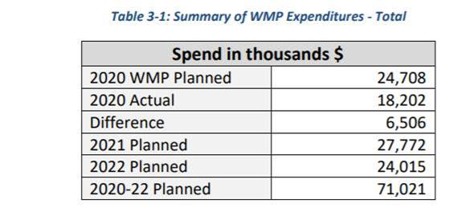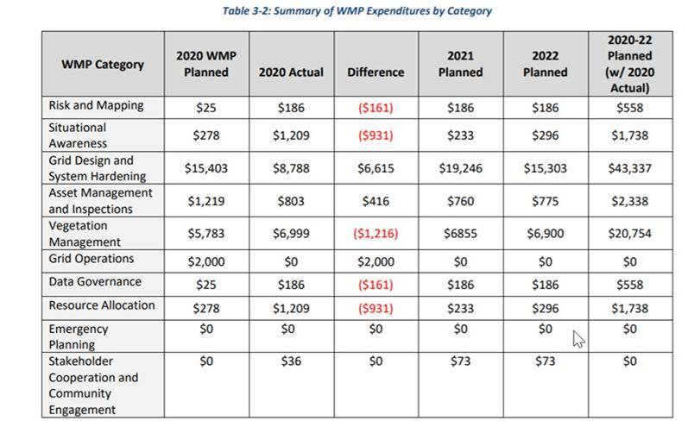

Reconcile the calculations listed above that do not match and confirm with the WSD which totals are accurate.

1. The “Difference” column from Table 3-2 in the Stakeholder Cooperation & Community Engagement row reports a $0 difference for this category, however, the 2020 WMP Planned spend is shown as $0 and the 2020 Actual spend is shown as $36,000. Based on these numbers, the difference should be +$36,000. Please confirm the correct difference.
2. PacifiCorp did not provide a current update for 8.4 “Engaging Vulnerable Communities” (p. 202). Please provide full, complete, current answers. Please do not exclusively refer the WSD to other sections of the WMP or outside reports. For example, the WMP Update answers the questions under 8.4 by pointing to “PSPS Phase 2 Progress Report,” but this report is from Aug. 2020, predating PacifiCorp’s 2020 PSPS events. For 8.4 “Engaging Vulnerable Communities, please:
3. *Describe protocols for PSPS that are intended to mitigate the public safety impacts of PSPS on vulnerable, marginalized and/or at-risk communities. Describe how the utility is identifying these communities.*
4. *List all languages which are “prevalent” in utility’s territory. A language is prevalent if it is spoken by 1,000 or more persons in the utility’s territory or if it is spoken by 5% or more of the population within a “public safety answering point” in the utility territory (D.20-03-004).*
5. *List all languages for which public outreach material is available, in written or oral form.*
6. *Detail the community outreach efforts for PSPS and wildfire-related outreach. Include efforts to reach all languages prevalent in utility territory.*
7. Populate columns F-I (highlighted in green) for each WMP initiative (rows 8-93) in the attached excel workbook titled “PC 2021 Table 12 DR TEMPLATE 20210402”. Do not deviate from the data validation list in columns F and H. For column J “Spend Aggregation”, the orange filled cells denote initiatives for which 2021 and/or 2022 spend is reported; list all WMP initiatives that are included in those spend totals.