Data Request Qs:

- In its response to 3/17/21 utility call question 1a, PC provided an Excel file with program targets. A few of the numbers provided do not match those in Table 5.43-5-1 (WMP p. 98). Below is a table presenting those discrepancies. Please reconcile each of the numbers shown in red with the numbers from WMP Table 5.43-5-1, specifically:
  - Weather Station Installations – 2020 Performance
  - Weather Station Installations – 2021 Target
  - Replacement of Cu Conductor – 2021 Target
  - Replacement of Cu Conductor – 2022 Target

“WSD_DR_3.17.21_Question 1(a).xlsx” vs. Table 5.43-5-1 (discrepancies shown in red)
Program Target | 2020 Performance | 2020 Performance (Table 5.43-5-1) | 2021 Target | 2021 Target (Table 5.43-5-1) | 2022 Target | 2022 Target (Table 5.43-5-1) | Units
Weather Station Installations | 9 | 2 | 20 | 22 | 14 | 14 | Stations
Replacement of Cu Conductor | 0 | 0 | 3.78 | 0 | 2.65 | 17.3 | Line Miles

RESPONSE:
A few equations were wrongly applied when compiling the data request as compared to WMP Table 5.43-5-1 and further reconciling with other tables and sections in the WMP. An error was also found in Table 5.43-5-1 regarding program targets for weather stations in 2021.

Specific to the 2020 Weather Station Reported Performance:
Program Target | 2020 Performance | 2020 Performance (Table 5.43-5-1) | CORRECTED 2020 PERFORMANCE | Description of Issue
Weather Station Installations | 9 | 2 | 2 | Discrepancies in how completion of weather stations were tracked via work orders an (purchased vs installed vs relocated across the calendar years). The correct number should be two weather stations installed in 2020 with the additional weather stations currently being installed.

Specific to the 2021 Weather Station Target:
Program Target | 2021 Target | 2021 Target (Table 5.43-5-1) | CORRECTED 2021 TARGET | Description of Issue
Weather Station Installations | 20 | 22 | 21 | This target includes 9 “carry-over” from 2020 and 12 additional locations. Cascading effects of wrongly attributed completed weather stations in 2020 led to further tracking errors.

Specific to the 2021 Target for replacement of Cu Conductor (small diameter conductor):
Program Target | 2021 Target | 2021 Target (Table 5.43-5-1) | CORRECTED 2021 TARGET | Description of Issue
Replacement of Cu Conductor | 3.78 | 0 | 3.78 | Target value incorrectly copied into Table 5.43-5-1 from Table 12.

Specific to the 2022 Target for replacement of Cu Conductor (small diameter conductor):
Program Target | 2022 Target | 2022 Target (Table 5.43-5-1) | CORRECTED 2022 TARGET | Description of Issue
Replacement of Cu Conductor | 2.65 | 17.3 | 2.65 | Target value incorrectly copied into Table 5.43-5-1 from Table 12.

A revised Table from 3/17/21 Utility Call has been attached showing these confirmation or changes highlighted in yellow with red text.

- In the 2021 WMP update, the program target table in section 5.3 (WMP pp. 98) conflicts with Attachment 1 Table 12 regarding the amount of completed and planned installations of weather stations. Please also answer the following questions regarding the utility’s weather station initiative:
  - Please confirm that the utility installed 11 weather stations in 2019.
  - Provide the number of weather stations that were planned for completion in 2020 but did not get installed by end the of 2020.
  - Provide the total number of weather stations PacifiCorp is planning to have installed as part of their weather station network by the end of 2022.

RESPONSE:
Errors have been identified as explained in the response to question 1 above. These errors have permeated through the total program units reported. To provide clarity, the table below includes the 2019/2020 actuals as well as the 2021, 2022, and aggregate 2019-2022 planned values.

2019 Actual | 2020 Actual | 2021 Plan | 2022 Plan | Total 2019-2022
10 | 2 | 21 | 14 | 47
Wrongly reported previously | Originally planned as 11;  8 stations delayed to facilitate more robust siting and moved to 2021 prior to fire season | Includes 11 originally planned for 2021 and 8 carry over from 2020 to be installed prior to fire season | No change | Includes cascading changes to record keeping

- 10 weather stations were fully installed in 2019.
- A total of 11 weather stations were planned for 2020, 2 of which were completed.
- Total planned by end of 2022 = 47

- Following the 3/17 utility call, PC provided a revised version of Table 4-5 (‘model or legacy’ ignition risk drivers) with each risk driver assigned a color to indicate risk level for "fire season" and "non fire season," ranked within each category. Please re-revise Table 4-5 to rank all risks relative to one another (not within each category but with all risks ranked relative to one another). It is only necessary to show the relative risk during fire season. The risks of highest overall concern should be at the top of the list. If multiple risk drivers are considered to have the same level of risk, please rank them side-by-side.

RESPONSE:
Below is the list of ignition risk drivers, ordered from highest to lowest risk. While numerically the company had grouped certain drivers at the same value, it has ordered them distinctly in the list below.
Ordered from highest to lowest
Wire down event
- Contact from object
- Equipment/facility failure
- Wire to wire contact
- Utility work/Operation
- Contamination
- Vandalism/Theft
- Other
- Unknown

- Within PC’s 2021 WMP Update, there are multiple instances of references to non-existent sections. For each of the following, please clarify which section(s) was meant to be referenced.
  - Please confirm that the fourteen references to sections located in "7.9.4" (which doesn't exist) are supposed to reference sections in 7.3.4, or clarify which section(s) are meant to be referenced.
RESPONSE: This was an incorrect reference, which should have read 7.3.4.
  - Please confirm that the reference to section “7.3.12” (which doesn’t exist) is supposed to reference section 7.3.10, or clarify which section is meant to be referenced.
RESPONSE: This should have referred to 7.3.10, Stakeholder cooperation and community engagement.
  - Please confirm that the two references to section “4.2.5” (which doesn’t exist) are supposed to reference section 4.2.2, or clarify which section(s) are meant to be referenced.
RESPONSE: Correct, this should have referred to 4.2.2, page 38-39.

- Summing the initiative spend amount provided in Table 12, three of the ten WMP initiative categories do not match the spend reported in Table 3-2, “Summary of WMP Expenditures by Category” (see below). Please reconcile the calculations that do not match and confirm which values are accurate.
- Data Governance: 2020 Actual, 2021 Planned, 2022 Planned, 2020-2022 Planned
- Resource Allocation Methodology: 2020 Actual, 2021 Planned, 2022 Planned, 2020-2022 Planned
- Stakeholder Cooperation & Community Engagement: 2020-2022 Planned

NOTE: due to the discrepancies above, the total spend (reported in Table 3-1) does not match the initiative spend total when summing the spends in Table 12.

When summing the WMP total cycle spend for each category in PacifiCorp’s Table 12, the following numbers are obtained (with discrepancies highlighted in red):

Category | 2020 Actual Total | 2021 Planned Total | 2022 Planned Total | Total WMP cycle spend
Risk Assessment & Mapping | $ 186,000.00 | $ 186,000.00 | $ 186,000.00 | $ 558,000.00
Situational Awareness & Forecasting | $ 1,209,123.63 | $ 233,200.00 | $ 295,600.00 | $ 1,737,923.63
Grid Design & System Hardening | $ 8,788,467.00 | $ 19,246,376.00 | $ 15,303,431.00 | $ 43,338,274.00
Asset Management & Inspections | $ 802,654.00 | $ 759,898.00 | $ 775,116.00 | $ 2,337,668.00
Vegetation Management & Inspections | $ 6,998,752.00 | $ 6,854,916.00 | $ 6,900,000.00 | $ 20,753,668.00
Grid Operations & Operating Protocols | $ - | $ - | $ - | $ -
Data Governance | $ 181,000.00 | $ 316,750.00 | $ 316,750.00 | $ 814,500.00
Resource Allocation Methodology | $ - | $ - | $ - | $ -
Emergency Planning & Preparedness | $ - | $ - | $ - | $ -
Stakeholder Cooperation & Community Engagement | $ 36,474.00 | $ 72,948.00 | $ 72,948.00 | $ 182,370.00
Total Planned Spend for WMP cycle | $ 18,202,470.63 | $ 27,670,088.00 | $ 23,849,845.00 | $ 69,722,403.63

However, PacifiCorp submitted Tables 3-1 and 3-2 in its 2021 WMP which contained the following numbers:

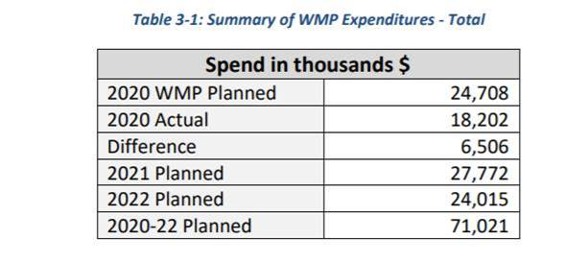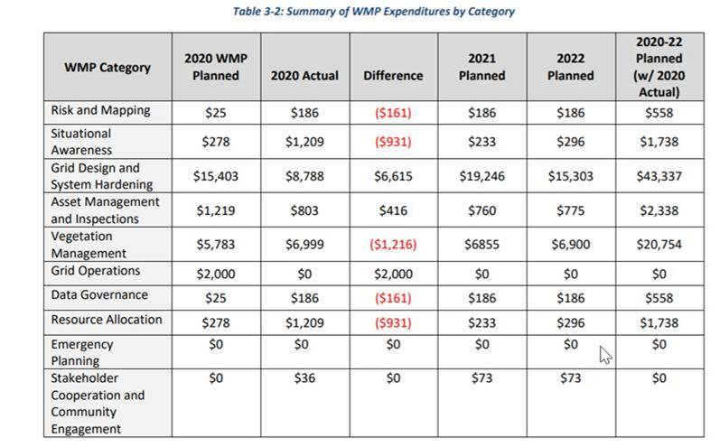

Reconcile the calculations listed above that do not match and confirm with the WSD which totals are accurate.

RESPONSE:
In general, calculation errors were made when translating and compiling values from Table 12 into Tables 3-1 and 3-2 regarding data governance and resource allocation and methodology. However, the detailed values in Table 12 should reflect the actual and planned costs.

Additionally, a copy and paste error occurred when aggregating the 2020 WMP Planned values and the 2020 planned costs for both risk assessment and mapping and situational awareness were used for resource allocation and data governance on accident.

Furthermore, as identified in question 6 below, the columns in Table 3-2 were added incorrectly for Stakeholder Cooperation and Community Engagement.

Tables 3-1 ad 3-2 have been recreated below to include the correct aggregate values for each category with the altered values shaded in yellow.

Table 3-1: Summary of WMP Expenditures – Total - REVISED
Spend in thousands $
2020 WMP Planned | $24,708
2020 Actual | $18,202
Difference | $6,506
2021 Planned | $27,670
2022 Planned | $23,850
2020-22 Planned | $69,722

Table 3-2: Summary of WMP Expenditures by Category - REVISED
WMP Category | 2020 WMP Planned | 2020 Actual | Difference | 2021 Planned | 2022 Planned | 2020-22 Planned  (w/2020 Actual)
Risk and Mapping | $25 | $186 | ($161) | $186 | $186 | $558
Situational Awareness | $278 | $1,209 | ($931) | $233 | $296 | $1,738
Grid Design and System Hardening | $15,403 | $8,788 | $6,615 | $19,246 | $15,303 | $43,337
Asset Management and Inspections | $1,219 | $803 | $416 | $760 | $775 | $2,338
Vegetation Management | $5,783 | $6,999 | ($1,216) | $6,855 | $6,900 | $20,754
Grid Operations | $2,000 | $0 | $2,000 | $0 | $0 | $0
Data Governance | $0 | $181 | ($181) | $317 | $317 | $815
Resource Allocation | $0 | $0 | $0 | $0 | $0 | $0
Emergency Planning | $0 | $0 | $0 | $0 | $0 | $0
Stakeholder Cooperation and Community Engagement | $0 | $36 | ($36) | $73 | $73 | $182
Total | $24,708 | $18,202 | $6,506 | $27,670 | $23,850 | $69,722

- The “Difference” column from Table 3-2 in the Stakeholder Cooperation & Community Engagement row reports a $0 difference for this category, however, the 2020 WMP Planned spend is shown as $0 and the 2020 Actual spend is shown as $36,000. Based on these numbers, the difference should be +$36,000. Please confirm the correct difference.

See Response to Question 7. This difference is correct and was incorporated into the revised Table 3-2.

- PacifiCorp did not provide a current update for 8.4 “Engaging Vulnerable Communities” (p. 202). Please provide full, complete, current answers. Please do not exclusively refer the WSD to other sections of the WMP or outside reports. For example, the WMP Update answers the questions under 8.4 by pointing to “PSPS Phase 2 Progress Report,” but this report is from Aug. 2020, predating PacifiCorp’s 2020 PSPS events. For 8.4 “Engaging Vulnerable Communities, please:
- Describe protocols for PSPS that are intended to mitigate the public safety impacts of PSPS on vulnerable, marginalized and/or at-risk communities. Describe how the utility is identifying these communities.

- List all languages which are “prevalent” in utility’s territory. A language is prevalent if it is spoken by 1,000 or more persons in the utility’s territory or if it is spoken by 5% or more of the population within a “public safety answering point” in the utility territory (D.20-03-004).

- List all languages for which public outreach material is available, in written or oral form.

- Detail the community outreach efforts for PSPS and wildfire-related outreach. Include efforts to reach all languages prevalent in utility territory.

It was PacifiCorp’s intent to Section 8.4 to reference the PSPS Phase 2 Progress Report filed in December of 2020. See attached for updates progress report. For additional information, PacifiCorp’s plan to address access and functional needs during de-energization events was also filed on February 1, 2021 and is attached for reference.

- Populate columns F-I (highlighted in green) for each WMP initiative (rows 8-93) in the attached excel workbook titled “PC 2021 Table 12 DR TEMPLATE 20210402”. Do not deviate from the data validation list in columns F and H. For column J “Spend Aggregation”, the orange filled cells denote initiatives for which 2021 and/or 2022 spend is reported; list all WMP initiatives that are included in those spend totals.

See attachment.

